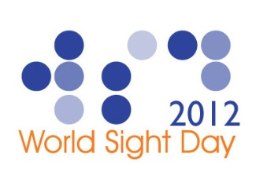
COMPREHENSIVE HEALTH AND EDUCATION FORUM (CHEF) INTERNATIONAL, PAKISTAN
CELEBRATES THE WORLD SIGHT DAY 2012

World Sight Day is an annual day of awareness to focus global attention on blindness, visual impairment and rehabilitation of the visually impaired held on the second Thursday in October.
World Sight Day is observed around the world by all partners involved in preventing visual impairment or restoring sight. It is also the main advocacy event for the prevention of blindness and for "Vision 2020:
For The Year 2012, World Sight Day theme was "The Integrated Eye Care Team – Working Together to Eliminate Avoidable Blindness." The World Sight Day’ as the name suggests, is a day that is dedicated to pledging perfect vision for every individual on earth. It is an event that receives global attention every year. The agencies involved help bring attention to vision related issues that are plaguing the world.
This year CHEF- International, Pakistan celebrated this very significant event with key focus on creation of public awareness regarding preventable causes of blindness. All the activities were organized involving eye care teams with the active community participation.

The teams placed at Ten Community Vision Centers (CVCs) of CHEF-International in different parts of the country organized multiple activities like public awareness walk, seminars and screening of school children for refractive errors or low vision.
The team of CVC Peshawar (KPK) in association with comprehensive eye care program team, fund raising department and human resource department of CHEF-International orchestrated a fund raising exhibition in which handicraft made by the female employees at CHEF International, students of the school for the blind, Peshawar and the Livelihood project (CHEF) collectively celebrated the World Sight Day 2012.
In addition to fund raising for the school for the blind, the exhibition also entailed free eye examination and eye health education in form of distributing eye health education materials to the people coming to the exhibition.
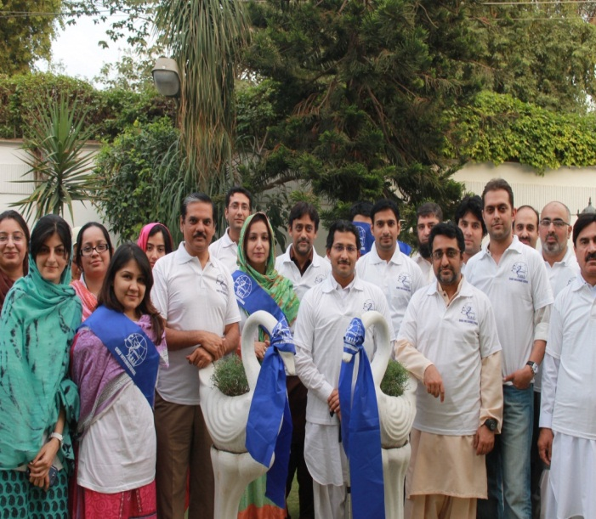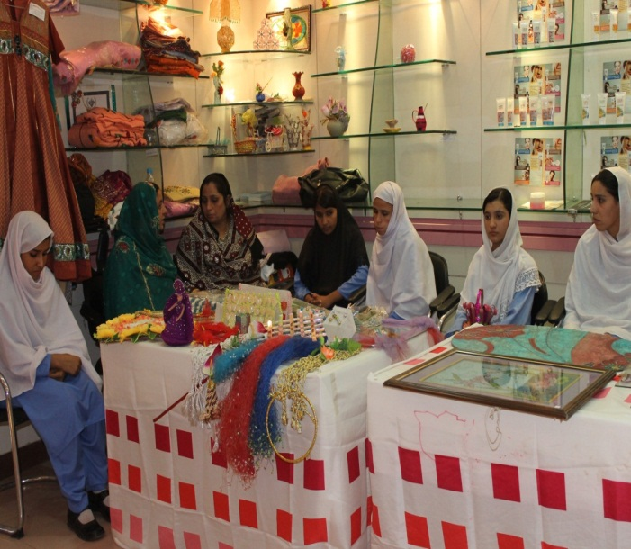
The team of CVC in Swabi District of KPK conducted a seminar at city convention hall wherein prominent people (district government officials, teachers, students and public) from all walks of life participated. At the conclusion of seminar, public awareness walk on the main Swabi-Jehangira Road was executed and led by many notable citizens.
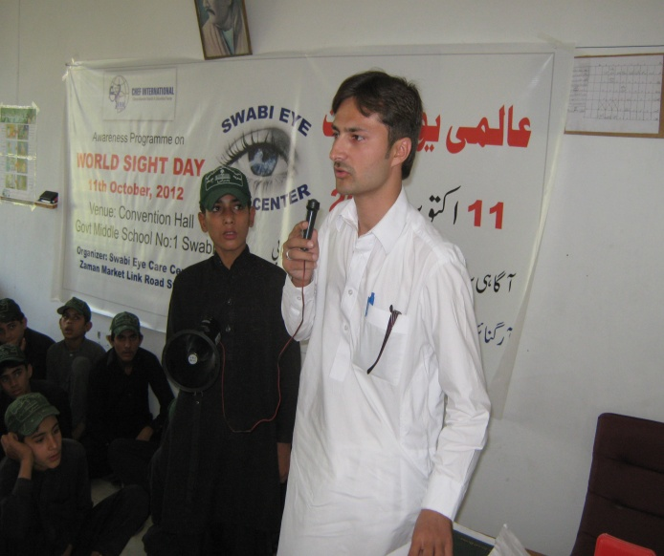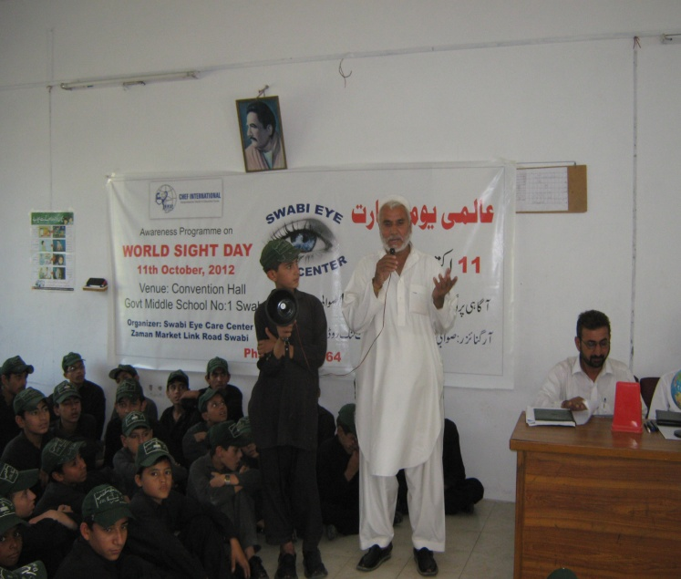
The team of CVC Hazro (Punjab) conducted awareness sessions in two schools and afterwards conducted the activity of vision screening in school children in the same schools (Elementary School for Girls & Government Primary School for Boys). A total of 280 children were screened for refractive errors and identification of eye diseases.
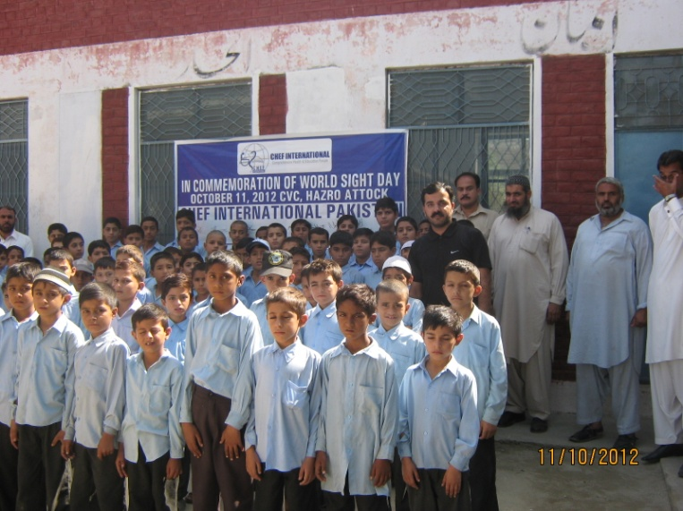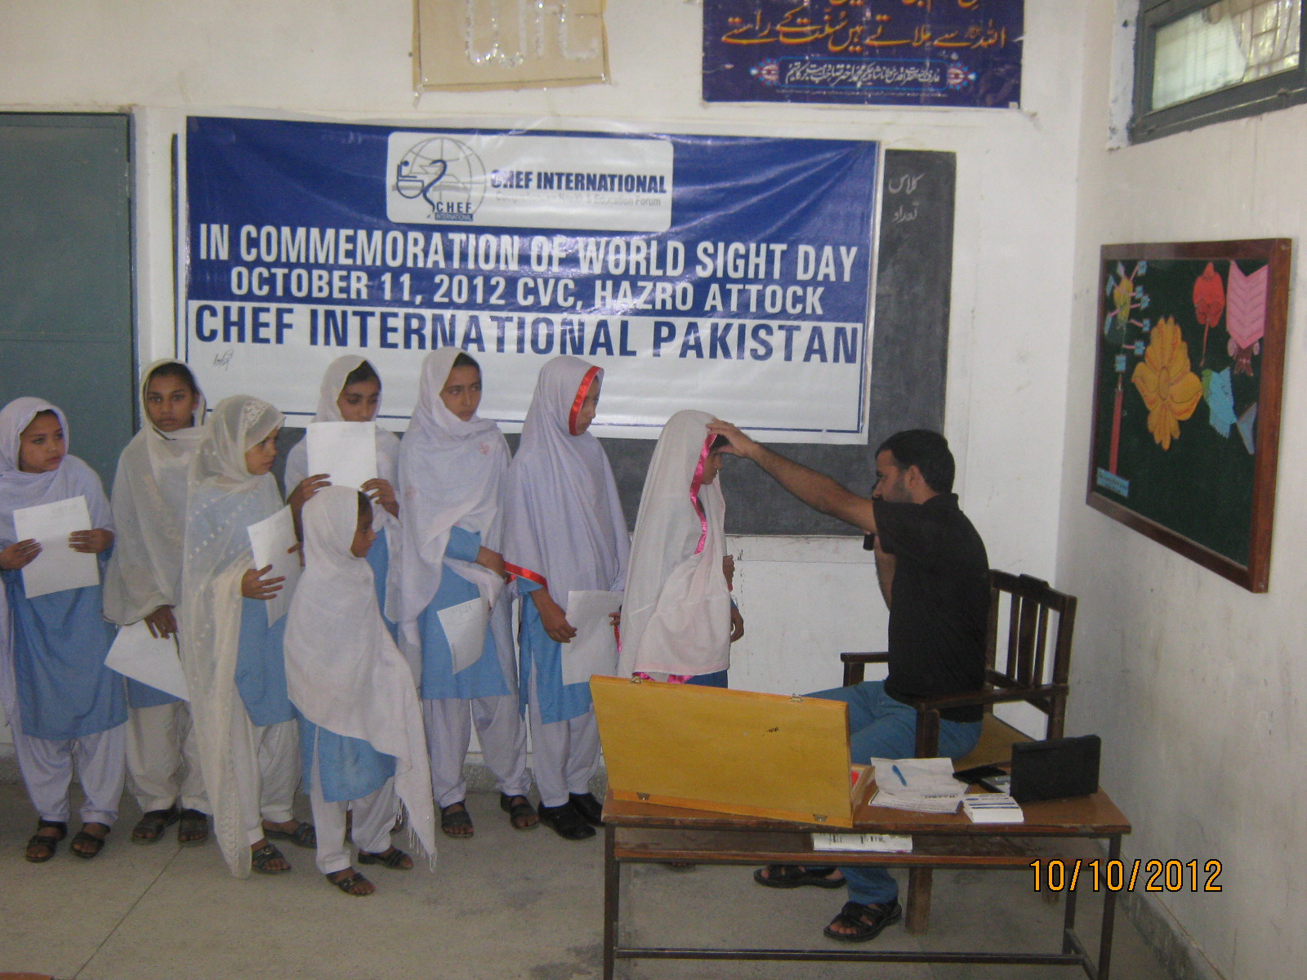
The team of CVC Haripur (KPK) organized an awareness session on primary eye care in superior public school and college, Haripur and afterwards conducted activity on vision screening of about 200 school children. The Team of CVC displayed a number of posters in Urdu for better understanding by the general public.
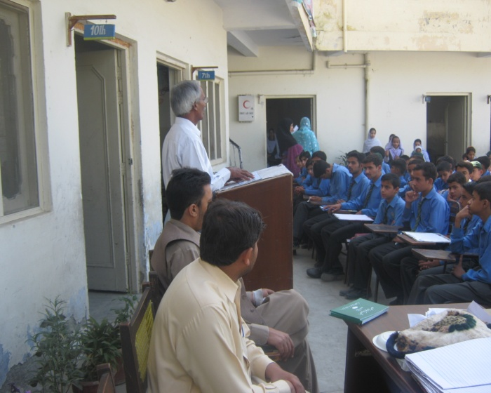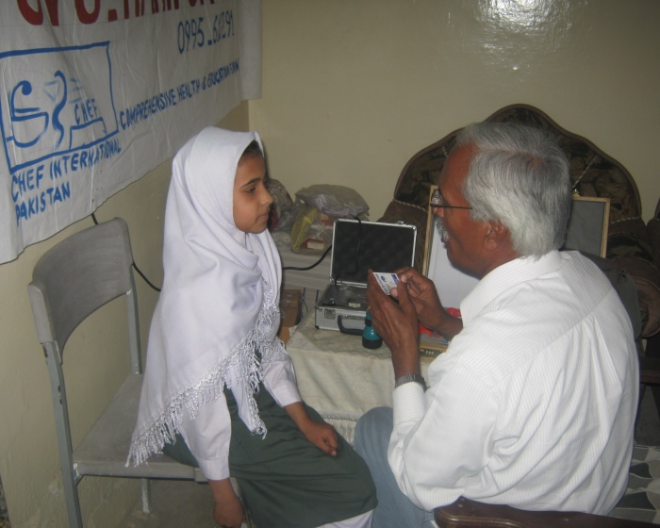
The team of CVC Quetta (Baluchistan) organized a vision screening camp in Pak Public School and screened 203 students along with giving health education.
The team of CVC Abbottabad (KPK) selected a local Madrissa school to celebrate world sight day with the students and teachers. Team screened the students and gave them awareness to recognize the early signs of cataract, glaucoma and other eye diseases to have understanding of preventable or avoidable blinding eye diseases.
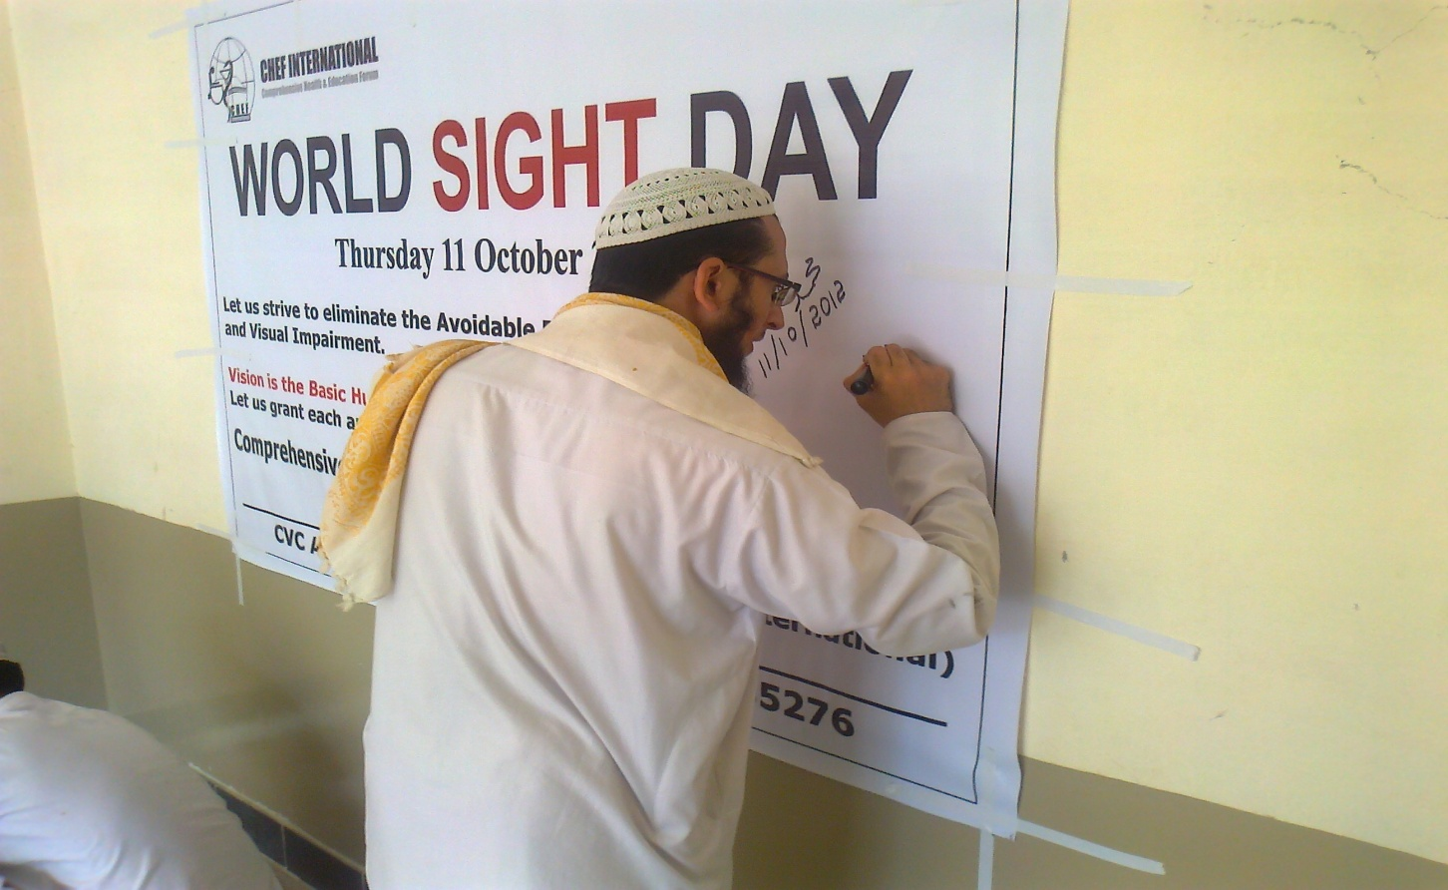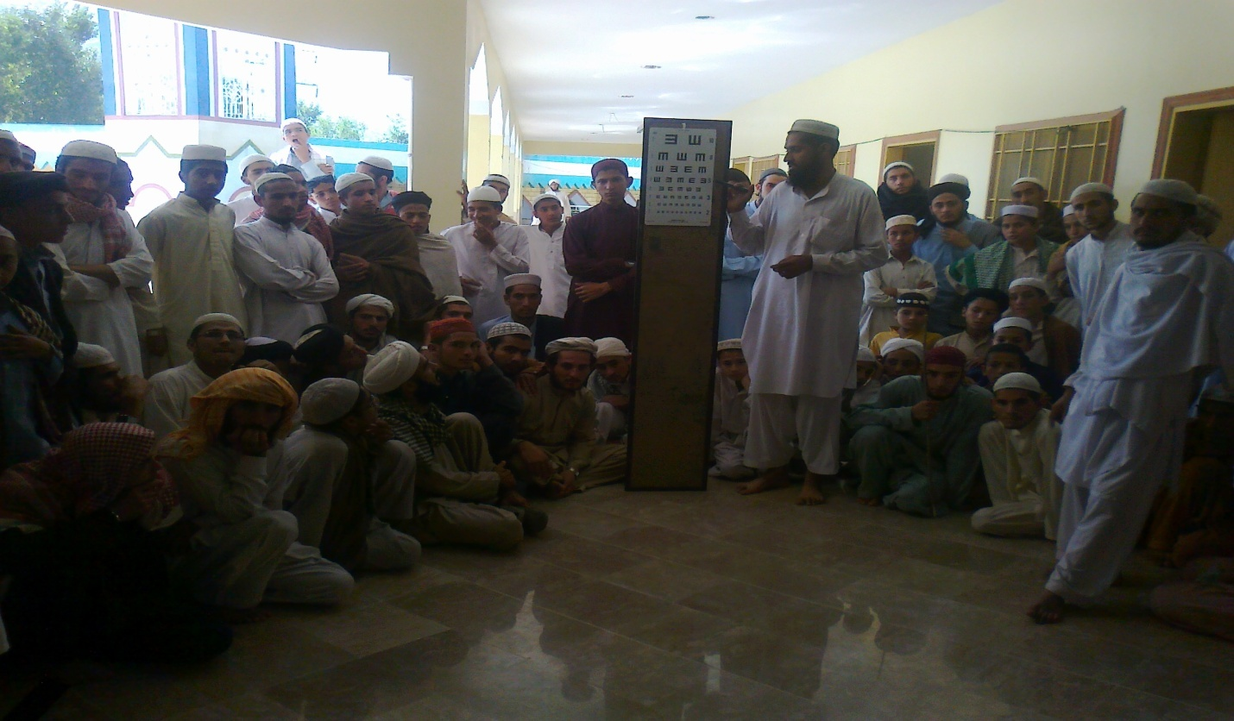
The team of CVC Murree (Punjab) conducted an eye health awareness seminar and vision screening camp at the Government Boys high School Darya Gali Murree. A good number of students, their parents and teachers attended the session. 138 students were screened for vision.
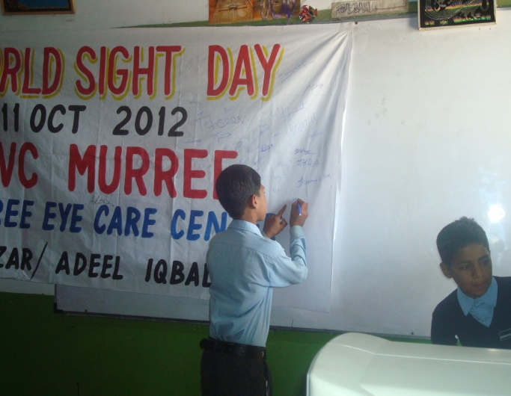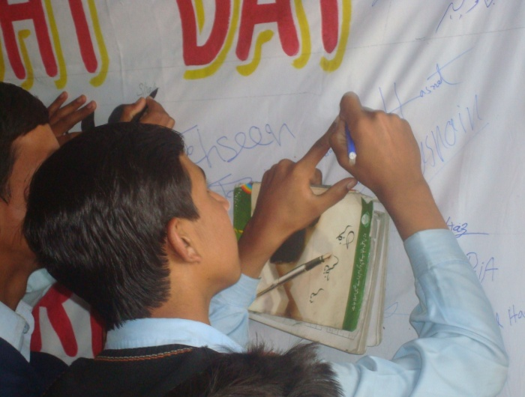
The team of CVC Mansehra (KPK) executed vision screening activity in two schools; Government Middle School for Boys and Govt. Primary school for boys in Bayee Payain. Team displayed banners and charts in schools for health education. They gave a session on the importance and reason to celebrate world sight day. 314 students were screened in both schools.
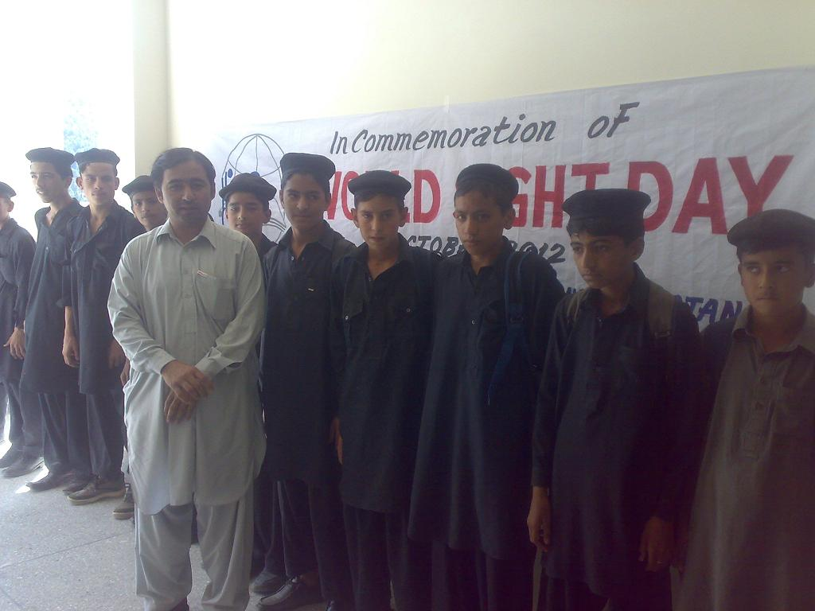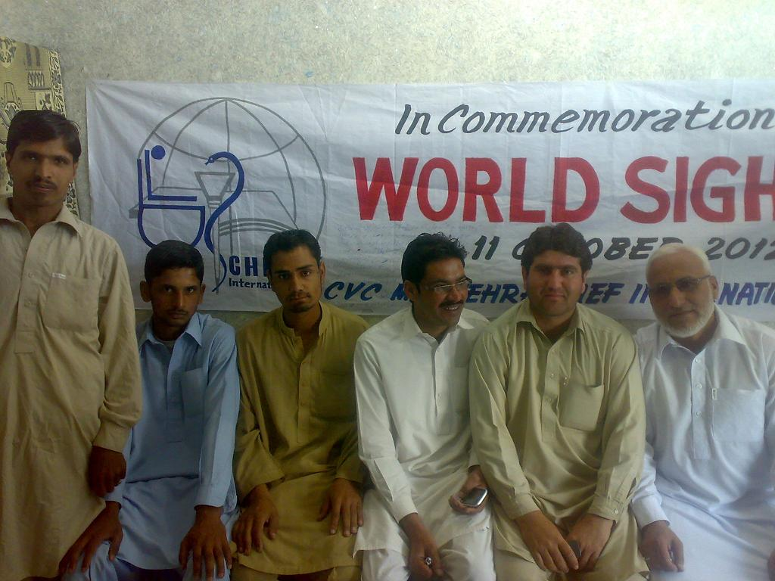
Similarly, the team of CVC Barakahu managed a community session on eye health especially focusing on primary eye care and pledging the commitment towards elimination of avoidable blindness in the area. The team also conducted an activity on vision screening of about 200 school children and eye camp for general public wherein the team examined 150 patients having different eye diseases. Health education brochures were also distributed.
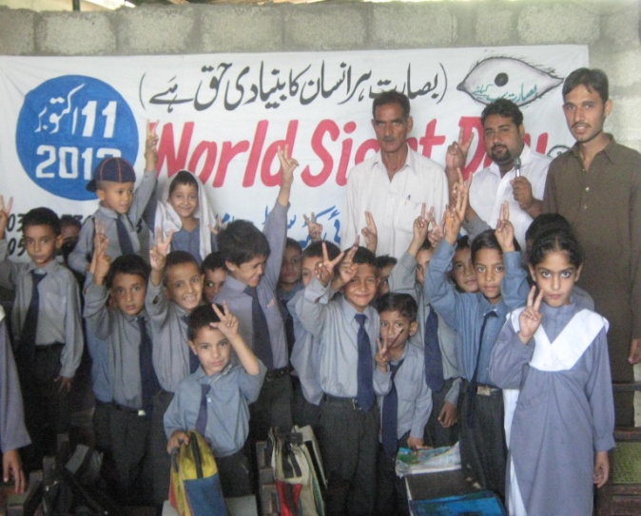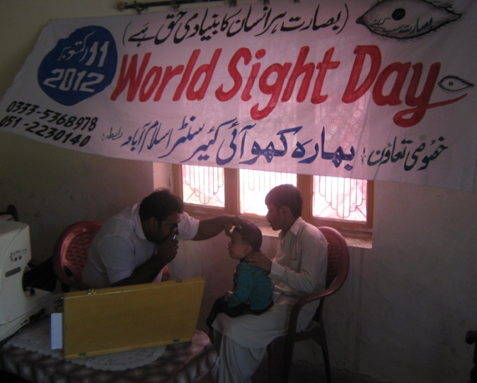
All these events mark the fact that CHEF International is stepping forward and promoting eye health and contributing to the goal of achieving Vision 2020 at various tiers.
………………………………………………………………………………………………
CHEF-INTERNATIONAL, PAKISTAN

